Just a Hook
Time Limit: 4000/2000 MS (Java/Others) Memory Limit: 32768/32768 K (Java/Others)
Total Submission(s): 5381 Accepted Submission(s): 2501
Problem Description
In the game of DotA, Pudge’s meat hook is actually the most horrible thing for most of the heroes. The hook is made up of several consecutive metallic sticks which are of the same length.
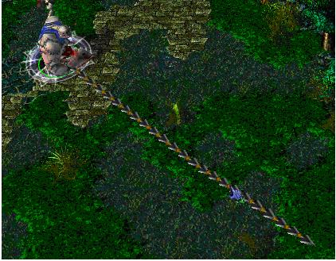
Now Pudge wants to do some operations on the hook.
Let us number the consecutive metallic sticks of the hook from 1 to N. For each operation, Pudge can change the consecutive metallic sticks, numbered from X to Y, into cupreous sticks, silver sticks or golden sticks.
The total value of the hook is calculated as the sum of values of N metallic sticks. More precisely, the value for each kind of stick is calculated as follows:
For each cupreous stick, the value is 1.
For each silver stick, the value is 2.
For each golden stick, the value is 3.
Pudge wants to know the total value of the hook after performing the operations.
You may consider the original hook is made up of cupreous sticks.

Input
The input consists of several test cases. The first line of the input is the number of the cases. There are no more than 10 cases.
For each case, the first line contains an integer N, 1<=N<=100,000, which is the number of the sticks of Pudge’s meat hook and the second line contains an integer Q, 0<=Q<=100,000, which is the number of the operations.
Next Q lines, each line contains three integers X, Y, 1<=X<=Y<=N, Z, 1<=Z<=3, which defines an operation: change the sticks numbered from X to Y into the metal kind Z, where Z=1 represents the cupreous kind, Z=2 represents the silver kind and Z=3 represents the golden kind.

Output
For each case, print a number in a line representing the total value of the hook after the operations. Use the format in the example.

Sample Input
1
10
2
1 5 2
5 9 3

Sample Output
Case 1: The total value of the hook is 24.

Source

//思路和 count color 相似
#include<iostream>
using namespace std;
int ans;
struct node
{
int l,r,met; //met代表金属的值，取1，2，3，当met=0 时代表该区间存在多种金属。
}a[300000];
void build(int i,int left,int right) //建树，每个区间的金属值初始为1.
{
a[i].l=left;
a[i].r=right;
a[i].met=1;
if(left==right)
return;
int mid=(left+right)>>1;
build(i<<1,left,mid);
build((i<<1)+1,mid+1,right);
}
void update(int i,int left,int right,int value) //更新操作
{
if(a[i].l==left && a[i].r==right) //找到要跟新的区间，更新之。
{
a[i].met=value;
return;
}
//还未找到区间。
if(a[i].met && a[i].met!=value) //若该区间是单种金属，且与要更新的金属不同
{
a[i<<1].met=a[(i<<1)+1].met=a[i].met; //给两个子区间赋值
a[i].met=0; //0,表示多种金属。
}
if(a[i].met==value) //若该区间的单金属且与要更新的金属相同，直接返回，不用更新。
return;
int mid=(a[i].l+a[i].r)>>1;
if(right<=mid)
update(i*2,left,right,value);
else
if(left>mid)
update(i*2+1,left,right,value);
else
{
update(i<<1,left,mid,value);
update((i<<1)+1,mid+1,right,value);
}
}
void find(int i,int left,int right)
{
if(a[i].met)
{
ans+=a[i].met*(right-left+1);
return;
}
int mid=(right+left)>>1;
find(i*2,left,mid);
find(i*2+1,mid+1,right);
}
int main()
{
int T,i,n,m,cases,p,q,value;
scanf("%d",&T);
for(cases=1;cases<=T;cases++)
{
scanf("%d%d",&n,&m);
build(1,1,n);
while(m--)
{
scanf("%d%d%d",&p,&q,&value);
update(1,p,q,value);
}

ans=0;
find(1,1,n);
printf("Case %d: The total value of the hook is %d.\n",cases,ans);
}
return 0;
}

